Project Name |  | Confidentiality Level
DBMS Project |  | For Recipients’ Reference Only
Project ID | Version | Document Code
58888 | 2.0 | 58888_SD_001

DBMS Software System Design Specification

Copyright © Ruankosoft Technologies(Shenzhen), Co., Ltd.
. All Rights Reserved
Revision Record
Date | Revision Version | CR ID /Defect ID | Sec No. | Change Description | Author
2017-4-26 | 1.0 |  |  | Finished introduction | 何方溥
2017-5-1 | 1.1 |  |  | Finished chapter 2,3,4,5 | 何方溥
2017-5-2 | 2.0 |  |  | Finished chapter 5,6,7 | 何方溥

Content
1 Introduction 5
1.1 Purpose 5
1.2 Scope 5
1.2.1 Name 5
1.2.2 Functions 5
1.2.3 Applications 5
2 Level 0 Design Description 5
2.1 Software System Context Definition 5
2.2 Design Considerations 5
2.2.1 Design Alternatives 5
2.2.2 Design Constraints 5
2.2.3 Other Design Considerations 6
3 Level 1 Design Description 6
3.1 System Architecture 6
3.1.1 Description of the Architecture 6
3.1.2 Representation of the Business Flow 6
3.2 Decomposition Description 6
3.2.1 Module/Subsystem 1 Description 6
3.2.2 Module/Subsystem 2 Description 6
3.3 Dependency Description 6
4 Level 2 Design Description (Optional) 6
4.1 Module Name 1 7
4.1.1 Design Description 7
4.1.2 Function Illustration 7
4.2 Module Name 2 7
4.2.1 Design Description 7
4.2.2 Function Illustration 7
5 Data Structure/Database Design 7
6 UI Design 7
7 Detailed Design of Module 8
7.1 Class1 Design 8
7.1.1 Overview 8
7.1.2 Class Diagram 8
7.1.3 Attributes 8
7.1.4 Methods 8
7.2 Class2 Design 9

Keywords:DBMS、RDBMS、MFC、SDI Dialog、C/S 、MVC
Abstract:This system is the version of the database management system, including database creation, database table management, record addition and query, index creation and implements, multi-user, concurrency processing, transaction procession, database backup and recovery, etc. This document describes the design of each functional module to help the software developers analyze and design the software better. At the same time, it helps the clients to give better suggestions.
List of abbreviations:
Abbreviations | Full spelling | Chinese explanation
SDI | Single Document Interface | 单文档界面
MFMFC | Microsoft Foundation Classes | 微软基础类库
DBMS | Relational Database Management System | 关系型数据库管理系统
C/S | Client/Server | 客户/服务器模式
MVC | Model View Controller | 模型（model）—视图（view）—控制器（controller）

- Introduction

Purpose
This document describes the DBMS’s design process, including general design and detailed design, in order to conduct project team to implement coding and unit testing. Expected reader of this specification is intermediate users (refers to project team member, client representative, testing staff, QA and etc.).

Scope
    - Name
DBMS (Database Management System)
    - Functions
Software functions please refer to the requirements specification document: requirement analysis of DBMS.
    - Applications

- Level 0 Design Description

Software System Context Definition
The architecture of the DBMS includes: DBMS architecture, user interface, syntax analysis, query processing, directory management, concurrency control, recovery mechanism, physical storage management, etc. This system mainly implements the basic functions of query processing, directory management, concurrency control, and recovery mechanism. The physical storage management directly utilizes the file management function of the operating system. The syntax analysis and user interface will not be implemented temporarily.
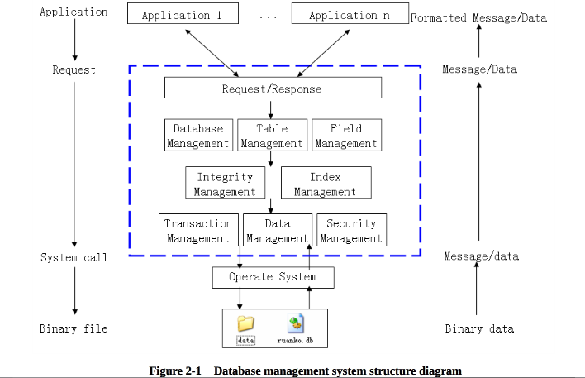
The system is a desktop application with window interface. The architecture is C/S structure. Many servers can be created on the whole network. Each server is responsible for its own data storage. Through the network, the client can connect to any or many servers. A server can provide service for many clients. The system architecture diagram is as follows:
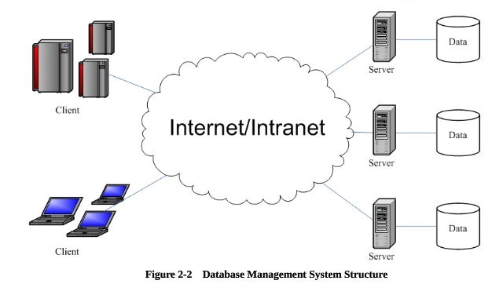

Design Considerations
    - Design Alternatives
- Program structure design
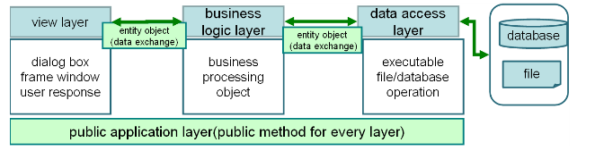
Based on the logic responsibility, the program software structure can be divided into 3 layers: presentation layer, business logic layer and data access layer. Data in each layer is transferred by “entity class” (data object). Besides, public class that irrelative with business may be used in layers in the program as the “Tool class”.

- Data Storage Structure
The system stores data with the binary file of the operating system, and saves the definition data and data information with the folder and file .DBMS system definition files include the database description file (ruanko.db), table description file (*.tb), table definition file (saves field information, *tdf), index description file (*.tid), integrity description file (*.tic). The data files of DBMS include the record file (*.trd), index data file (*.ix), log file (*.log), transaction data file (*.tac), temporary file (*.tmp), ect.
The relation diagram between the database description file, table description file, table definition file and record file is as follows:
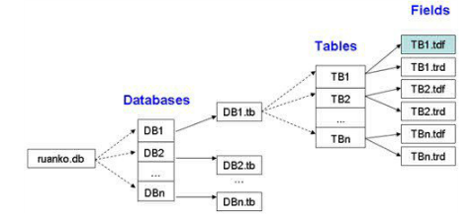
    - Design Constraints
      - Standards compliance
Could expand the specifications that do not exist in the following requirements, but it cannot contrary to the standard. It follows: <COE technical requirement standard of Ruanko Lab>, <COE programming standard requirement of Ruanko Lab>.
      - Technology Limitations
Parallel operation: Allow multiple user access the database at the same time, and ensure the correctness and completeness of the data.
Coding standard: COE programming standard requirement of Ruanko Lab.
- Level 1 Design Description

System Architecture
The system is developed according to the thought of “divide and rule”. The functions are divided into many modules to manage and develop individually. The detailed module division of the system is shown below:
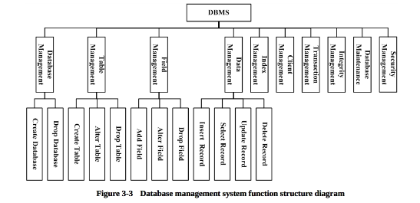
Modules are divided according to three-layer structure and shown below:
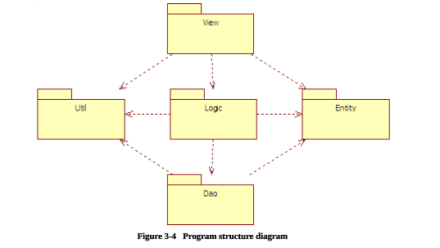
- Project Structure
The system is divided into 2 main parts of the database server project and database enterprise manager. The client is a SDI project. The server is a dialog project.
The project name of the client is RKDBMS.
The project structure is shown below:
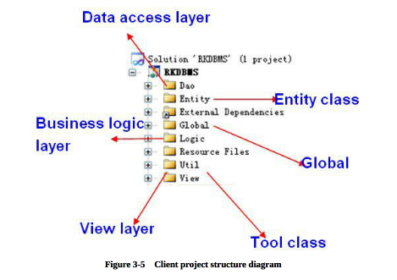
(The structure of server program is the same as the client.)
- Project program structure
Make logic to program by VS2010 Solution Explorer through Filter.
Layer | Filter | Class
View layer | View | Frame class-CMainFrame  View class-CRKDBMSView  Dislog box class
Business logic layer | logic | Document class-CRKDBMSDoc  Business logic process class
Data access layer | Dao | The class of writing and reading operation on data file
 | Entity | Entity class
 | util | Tool class
 | global | Global defined file  Application class--CRKDBMSApp

Decomposition Description

    - Database Management
- Overview
Create and delete the database. Implement database definition file creation, modification and query.
- Functions
Module Name | Function Name | Function Description
Database Management | Create Database | Implement the function of database creation. Corresponding SQL statement: CREATE DATABASE <database name>.
Database Management | Drop Database | Implement the function of database deletion. Corresponding SQL statement: DROP DATABASE <database name>.

    - Table Management
- Overview
Finish the functions of table creation, modification and deletion. Implement the table description file creation and update.
- Functions
Module Name | Function Name | Function Description
Table Management | Create Table | Implement database table creation function. Corresponding SQL statement: CREATE TABLE <table name>.
Table Management | Alter Table | Implement database table modification function. Corresponding SQL statement: ALTER TABLE <table name> <alter table action>.
Table Management | Drop Table | Implement database table deletion function. Corresponding SQL statement: Drop TABLE <table name> .
    - Field Management
- Overview
Finish the functions of table field addition, modification and deletion. Implement table field definition file creation, modification and query.
- Functions
Module Name | Function Name | Function Description
Field Management | Add Field | In created table, add fields. Corresponding SQL statement: ALTER TABLE <table name> ADD COLUMN <column name> <column definition>.
Field Management | Alter Field | Modify the field information in the table. Corresponding SQL statement: ALTER TABLE <table name> MODIFY COLUMN <column name> <alter column action>.
Field Management | Drop Field | Delete the field in the table. Corresponding SQL statement: ALTER TABLE <table name> DROP COLUMN <column name> <drop behavior>.
    - Data Management
- Overview
Implement the functions of data storage, update, modification and query..
- Functions
Module Name | Function Name | Function Description
Data Management | Insert Record | Insert a record into the database table. Corresponding SQL statement: INSERT INTO <table name> <column name list> VALUES <insert value list>.
Data Management | Update Record | Update the record in the database table. Corresponding SQL statement: UPDATE <table name> SET <column name> = <update value> [WHERE <search condition>].
Data Management | Select Record | Query all the table in the table. Corresponding SQL statement: SELECT * FROM <table name> [WHERE <search condition>].
Data Management | Delete Record | Delete the record in the table. Corresponding SQL statement: DELETE FROM <table name> [WHERE <search condition>].
    - Index Management
Establish the index for the key field in the database table. In the data operation, optimize the query with the index.
    - Client Management
Implement the client-server structure. The client can connect to main servers. The server can provide service for many clients.
    - Transaction Management
Implement transaction management function in the database.
    - Integrity Management
Implement the functions of database integrity constraint check and management.
    - Database Management
Implement the functions of database backup and recovery
    - Security Management
Implement user management, permission management.

Dependency Description
This project is a Windows window program and depends on the operating system. The data storage depends on the file management system of the operating system. The communication between the server and client depends on TCP/IP network communication protocol.
- Level 2 Design Description (Optional)

- Data Structure/Database Design
5.1 Data type
System data type | Description | Size | Program data type
INTEGER | Integer type | 4 byte | Int
BOOL | Boolean type | 1 byte | Bool
DOUBLE | Float type | 2 byte | Double
VARCHAR(n) | String type, maximum length is 255, ended with “\0” to mark the end of a string | (n+1) byte | Char[n+1]
DATETIME | Data time type | 16 byte | SYSTEMTIME
5.2 Integrity
5.2.1 Entity Integrity
PRIMARY KEY
5.2.2 Referential Integrity
FOREIGN KEY
5.2.3 User-defined Integrity
1. CHECK
2. UNIQUE
3. NOT NULL
4. DEFAULT
5. IDENTITY
5.3 Database file
This system is a relational database management system. It stores data with the binary file.
- File Design
The files in DBMS are mainly divided into two types: data definition file and data file
- Data definition file: saves the definitions of various objects in DBMS.
- Data file: saves various data in DBMS.
Type | File | Name | Remark
Data definition file | Database description file | Ruanko.db | Save the database information.
Data definition file | Table description file | *.tb | Save the table information.
Data definition file | Table definition file | *.tdf | Save the field information.
Data definition file | Integrity description file | *.tic | Save the integrity constrains.
Data definition file | Index description file | *.tid | Save the definition of the index.
Data File | Record File | *.trd
Data File | Index data file | *.ix
Data File | Log file | *.log
- File Structure
The database management system supports multi-databases. A database can include many tables. A table includes the data of the table information, integrity constraint, index, record and so on.
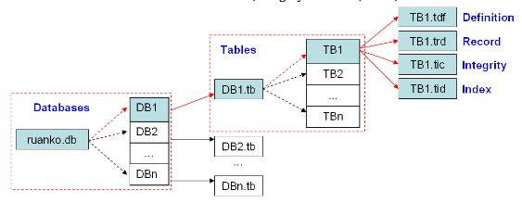
- Directory Structure
Taking [DBMS_ROOT] as the root directory, each database creates a folder to save various files in the database. Path:[DBMS_ROOT]\data\DB_NAME\.
Example: create a “Ruanko” database, and create “Student” table in the database. The presented directory structure is as follows:
File | Path
Database description file | [DBMS_ROOT]\ruanko.db
Table description file | [DBMS_ROOT]\data\Ruanko\Ruanko.tb
Table definition file | [DBMS_ROOT]\data\Ruanko\Student.tdf
Record file | [DBMS_ROOT]\data\Ruanko\Student.trd
Integrity description file | [DBMS_ROOT]\data\Ruanko\Student.tic
Index description file | [DBMS_ROOT]\data\Ruanko\Student.tid
5.4 Database Description File
5.4.1 File Name
Ruanko.db
5.4.2 File Structure
DatabaseBlock 1 | DatabaseBlock 2 | …… | DatabaseBlock N
5.4.3 Database Information Structure
Structure Member | Data type | Description
name | CHAR[128] | Database Name
type | BOOL | Database type
filename | CHAR[256] | The database file path
crtime | DATETIME | Creation time
5.5 Table Description File
5.5.1 File Name
[Database_Name].tb
5.5.2 File Structure
TableBlock 1 | TableBlock 2 | …… | TableBlock N
5.5.3 Database Information Structure
Structure Member | Data type | Description
name | CHAR[128] | Table Name
record_num | INTEGER | Records number
field_num | INTEGER | Fields number
tdf | CHAR[256] | The path of table definition file.
tic | CHAR[256] | The path of integrity description file
trd | CHAR[256] | The path of record file
tid | CHAR[256] | The path of index data file
crtime | DATETIME | Table creation time
mtime | DATETIME | Last modification time
5.6 Table Definition File
5.6.1 File Name
[Table_Name].tdf
5.6.2 File Structure
FieldBlock 1 | FieldBlock 2 | …… | FieldBlock N
5.6.3 Database Information Structure
Structure Member | Data type | Description
order | INTEGER | Field order
name | CHAR[128] | Field Name
type | INTEGER | Field type
param | INTEGER | Field type parameter
mtime | DATETIME | Last modification time
integrities | INTEGER | Integrity constraints
5.7 Record File
5.7.1 File Name
[Table_Name].trd
5.7.2 File Structure
Record 1 | Record 2 | …… | Record N
5.7.3 Record Information Structure
1. In DBMS, a record store format by user-defined.
2. Based on the characteristic of data storage, all of the blocks and the field size are stored in the adjustment of a multiple of 4, in order to improve the efficiency of the data read.
5.8 Integrity Description File
5.8.1 File Name
[Table_Name].tic
5.8.2 File Structure
Integrity 1 | Integrity 2 | …… | Integrity N
5.8.3 Database Information Structure
Structure Member | Data type | Description
name | CHAR[128] | Integrity Name
field | CHAR[128] | Field name
type | INTEGER | type
param | CHAR[256] | parameter
5.9 Index Description File
5.9.1 File Name
[Table_Name].tid
5.9.2 File Structure
IndexBlock 1 | IndexBlock 2 | …… | IndexBlock N
5.9.3 Database Information Structure
Structure Member | Data type | Description
name | CHAR[128] | Name
unique | BOOLEAN | Unique index
asc | BOOLEAN | Order type
Field_num | INTEGER | Fields number
fields | CHAR[128][2] | Field value
Record_file | CHAR[256] | The path of index record file
Index_file | CHAR[256] | The path indx data file
5.9.4 Index data file
File Name: [index_name].ix
Folder: table folder
Index Name: [Field_Name]Index

- UI Design(expamles)

Main Interface
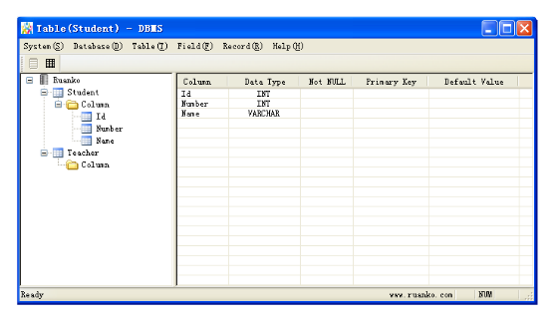

Show Table Structure Interface
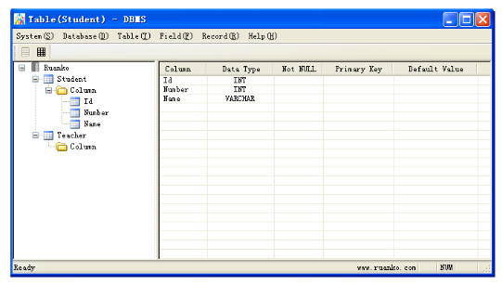

Select Record Interface
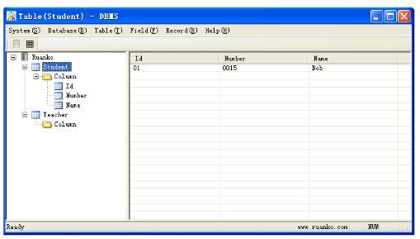

Create Table Interface
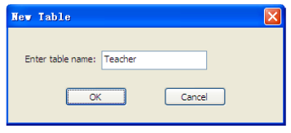

Add Field Interface
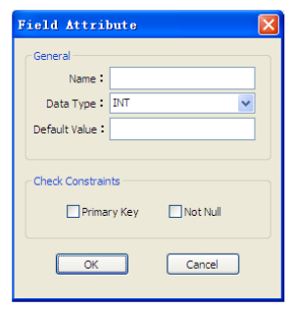

Insert Record Interface
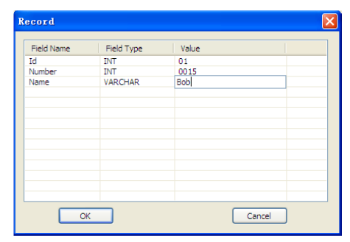

- Detailed Design of Module

DataStructure.h
    - Overview
Define the data type of the DBMS.
    - DatabaseBlock
      - Overview
Database information block
      - Definition
Struct DatabaseBlock{
BOOL type; //Database type
VARCHAR name; //Database name
VARCHAR filepath; //Databae file path
DATETIME crtime; //Creation time
};

    - TableBlock
      - Overview
Table information block.
      - Definition
Struct TableBlock{
VARCHAR name; //table anme
INTEGER record_num; //Record number
INTEGER field_num; //Field number
VARCHAR tdf; //Path of the table description file
VARCHAR trd; //path of the record file
DATETIME crtime; //table creation time
DATETIME mtime; //last modification time
};
    - FieldBlock
      - Overview
Field information block.
      - Definition
Struct FieldBlock{
VARCHAR name; //Field name
INTEGER type; //Field type
INTEGER param; // parameter
DATETIME mtime; //Last modification time
INTEGER integrities; //Integrity constraints
};

Global.h file
    - Overview
Macro definition file.
    - Macro
Macro Name | Value | Description
UPDATE_OPEN_DATABASE | 0x01 | Open database message
UPDATE_CREATE_TABLE | 0x02 | Create table message
UPDATE_EDIT_TABLE | 0x03 | Alter table message
UPDATE_ADD_FIELD | 0x04 | Add field message
UPDATE_OPEN_TABLE | 0x05 | Select record message
UPDATE_INSERT_RECORD | 0x06 | Insert record message
MENU_DATABASE | 1 | Database menu number
MENU_TABLE | 2 | Table menu number
MENU_FIELD | 3 | Field menu number
MENU_RECORD | 4 | Record menu number
MENU_OTHER | -1 | Other menu number

Entity Class
The entity class object is used to pass data between layers. The entity class is mainly composed of 3 parts:
- Private data member
Correspond to the properties of entity one to one.
- SetXXX() and GetXXX() functions
Access permission is public that is used to access the private data members in the class, and corresponds to the private data members one to one.
- SetXXX()function: assign values to private data members with parameters. Start with Set prefix , and followed by the property name. The first letter of the property name is uppercase. Generally, the return value of SetXXX() function is void. The parameter is consistent with the type of the corresponding data member.
- GetXXX() function: get the value of the private data member with the return value. The type of GetXXX() is consistent with the type of the corresponding data member. The parameter is void.
- Non-parameter Constructor
It is used to initialize the private property, and assign initial value to the property. If the property has not been initialized, the exception may appear when the unassigned property is passed between layers. When the unassigned property is displayed on the interface null may appear that is not friendly for users.
The entity classed of the system as follows:
Class Name | Description
CDBEntity | The entity class of database
CTableEntity | The entity class of table
CFiledEntity | The entity class of field
CRecordEntity | The entity class of record

View/Dialog Class
    - CDBview
- Overview
Shows the database structure view class, inherit from CTree view.
- Methods
Prototype | Function
Virtual void OnInitialUpdate() | View initialization function, initialize tree view.
Virtual void OnUpdate(CView* pSender, LPARAM lHint, CObject* pHint) | View update function
HTREEITEM AddTableNode(CTableEntity* pTable) | Add table node in the tree control.
HTREEITEM AddFieldNode(CFieldEntity* pField, HTREEITEM hTableItem) | Add field item to the tree control.
HTREEITEM GetTableItem(CString strTableName) | Get table item according to the table name.
    - CTableView
- Overview
Table structure view class, display table structure, inherit from CListView.
- Methods
Prototype | Function
Virtual void OnInitialUpdate() | View initialization function, initialize list view
Virtual void OnUpdate(CView* pSender, LPARAM lHint, CObject* pHint) | View update function
    - CRecordsView
- Overview
Display record views, inherit from CListView.
- Methods
Prototype | Function
Virtual void OnInitialUpdate() | View initialization function, initialize list view
Virtual void OnUpdate(CView* pSender, LPARAM lHint, CObject* pHint) | View update function
Void AddRecord(CRecordEntity* pRecord) | Display the record information in the list.
    - CNewTableDlg
New table dislog class.
    - CFieldDlg
- Overview
Field properties dialog box class, inherit from CDialogEx.
- Methods
Prototype | Function
Virtual BOOL OnInitDialog() | Dialog initialization function
Afx_msg void OnBnClickedOk() | OK button BN_CLICKED message response function, save the input field information to the field entity object.
    - CRecordDlg
- Overview
Record dialog box.
- Methods
Prototype | Function
Virtual BOOL OnInitDialog() | Dialog initialization function
Afx_msg void OnClickListData(NMHDR *pNMHDR, LRESULT *pResult) | Response function of list control clicked event, edit the value of the field.
Afx_msg void OnKillfocusEditValue() | The edit control lost the keyboard focus, assign the value of the edit control to list control.

Logic Class
    - CDBLogic
- Overview
Database business logic class.
- Methods
Prototype | Function
Bool CreateDatabase(CDBEntity &db) | Create database
Bool GetDatabase(CDBEntity &db) | Query database
    - CTableLogic
- Overview
Table business logic class.
- Methods
Prototype | Function
Bool CreteTable(const CString strDBName, CTableEntity &te) | Create a table
Bool AddField(const CString strDBName, CTableEntity &te, CTableEntity &fe) | Add field
Int GetTables(const CString strDBName, TABLEARR &arrTables) | Query table information.
    - CRecordLogic
- Overview
Data record business logic class.
- Methods
Prototype | Function
Bool Insert(const CString strDBName, CTableEntity &te, CTableEntity &re) | Create new rows in a table.
Bool SelectAll(CTableEntity &te, RECORDARR &dara) | Retrieve all records from a specified table.
    - CFileLogic
- Overview
Data record business logic class.
- Methods
Prototype | Function
CString GetDBFile() | Get the path of the database description file.
CString GetDBFolder(const CString strDBName) | Get the path of the database folder.
CString GetTableFile(const CString strDBName) | Get the path of the database table description file.
CString GetTbDefineFile(const CString strDBName, const CString strTableName) | Get the path of the table definition file.
CString GetTbRecordFile(const CString strDBName, const CString strTableName) | Get the path of the table record file.
CString GetAbsolutePath(const CString strRelativePath) | Change relative path into an absolute path.

Dao Class
    - CDBDao
- Overview
Database data operation class.
- Methods
Prototype | Function
Bool Create(const CString strFilepath, CDBEntity db, bool bAppend = true) | Create database
Bool GetDatabase(const CString strFilepath, CDBEntity &db) | Read the database information
    - CTableDao
- Overview
Table data operation class.
- Methods
Prototype | Function
Bool Create(const CString strFilepath, CTableEntity &te) | Create table and save table information
Bool AddFile(const CString strFilepath, CTableEntity &fe) | Add a table field
Int GetTables(const CString strFilepath, TABLEARR &arr) | Get table information
Bool getFields(const CString strFilepath, CTableEntity &te) | Get table information
Bool AlterTable(const CString strFilepath, CTableEntity &te) | Alter table
    - CRecordDao
- Overview
Record data operation class.
- Methods
Prototype | Function
Bool Insert(CTableEntity &te, CRecordEntity &re) | Create new rows in a table
Int SelectAll(CTableEntity &te, RECORDARR &data) | Retrieve all records from a specified table
Bool Write(CFile &file, CTableEntity &te, CRecordEntity &re) | Save record
Bool Read(CFile &file, CTableEntity &te, CRecordEntity &re) | Get record

Helper Class
    - CFileHelper
- Overview
File operations tool class.
- Methods
Prototype | Function
Static bool createFile(const CString strFileName) | Create file
Static bool IsValidFile(const CString strPath) | Decide the effectiveness of the file
    - CCharHelper
- Overview
Character processing tool class.
- Methods
Prototype | Function
Static void toChars(char* pDim, CString strSrc, const int nSize) | Convert CString type into char* type
Static void toChars(char* pDim, SYSTEMTIME tSrc, const int nSize) | Convert SYSTEMTIME type into char* type
Static void toChars(char* pDim, bool bVal, const int nSize) | Convert bool type into char* type
Static void toChars(char* pDim, int nVal, const int nSize) | Convert int type into char* type
Static void toChars(char* pDim, double dbVal, const int nSize) | Convert double type into char* type
Static CString toString(char* pSrc, const int nSize) | Convert char* type into CString type
Static void Copy(char* pDim, char* pSrc, const int nSize) | Copy char array
    - CTimeHelper
- Overview
Time processing tool class.
- Methods
Prototype | Function
Static SYSTEMTIME toSystemTime(CString strtime) | Convert CString type into SYSTEMTIME type.  Yyyy-mm-dd hh:mm:ss SSS
Static SYSTEMTIME toSystemTime(CTime t) | Convert CTime type into SYSTEMTIME type.
Static CTime toSystemTime(SYSTEMTIME st) | Convert SYSTEMTIME type into CTime type.

CMainFrame
- Overview
The frame window class, provide the application’s window.
- Methods
Prototype | Function
Virtual bool onCreateClient(LPCREATESTRUCT lpcs, CCreateContext* pContext) | Split window
Void SwitchView(int nViewType) | Switch the view

CRKDBMSDoc
- Overview
Document class, implement procedures logic operation related to the interface, and maintain and manage data.
- Methods
Prototype | Function
Bool OnNewDocument() | Create document
CDBEntity GetDBEntity() | Get the database entities
CTableEntity* CreateTable(CString strName) | Create table
CFieldEntity* AddField(CFieldEntity & field) | Add field
Void LoadTables() | Load tables
CRecordEntity* InsertRecord(CRecordEntity &record) | Insert a record
Void LoadRecord() | Query all the records

CAppException
- Overview
A custom exception class, the exception handler.
- Methods
Prototype | Function
CAppException(CString strError) | Overloaded constructor, constructor an exception object base on the error information.

Error Design
For the program, define unified exception class CAppException, and process the exception with try, catch, throw. When the underlying exception appears, throw the exception class to higher layer, and include the exception information. The exception structure is shown below:
